Helwan University

Faculty of Computers and Artificial Intelligence

Software Engineering Program

Graduation Project Proposal

“IsFake”

Detect Fake Voice Application

Presented by

|  |  |
| --- | --- |
| Name | ID |
| Mahamoud Sameh Fangary | 20211889 |
| Mohamed Mostafa AbdElMonsef | 20211886 |
| Hady Gamal Mohamed | 20211911 |
| Omar Mohamed Montaser | 20211863 |

Under the Supervision of **Dr. Hanan Fahmy**

September 2023

Table of Contents

1. Overview
   1. Introduction and Background
   2. Solution Overview
   3. Technology Stack
   4. Document Overview

1. User Requirements
   1. Functional Requirements
      1. User Interface (UI)
         1. Admin
         2. User
   2. Non-Functional Requirements   
      3.0 conclusion
2. Overview
   1. Introduction and Background

This document outlines the scope, key features, and timeline for the development of “IsFake”, a Detect Fake Voice application. The proposed application and website will enable users to detect is the voice you put is real or fake.

* 1. Solution Overview

“IsFake” Web Site will be developed using up to date technologies to ensure a seamless user experience and robust security. The key features of the proposed system are as follows:

* User Registration and Login: Users will be able to create accounts and log in securely to access the application's features and functionalities.

* Data from user: first user should give us some voices which will be stored in database to be compared with the test voice.

* Train the model : After user send some voices and it is stored model can train from it.
* User can put voice to be try the model :
  + - First should be asked if user which login will try the program from his data that is stored or create new data.
    - Same user and data, so he can send from 5 to 10 voices to ensure it will give a high accuracy and send it to model.
    - If he try for another voice first he will send some voice to check and train the model then put it data and voice which want to check it is real or not.
* Model Accuracy : User will see if its voice fake or not by accuracy.

* Some features show to user: user will some diagrams and dashboard to know his history.

1.3 Technology Stack

The proposed technology stack for the development of this application includes:

* Front-end: Angular Or React
* Back-end: ASP.NET Core
* Database: SQL server
* Fake Voice Recognition: Machine Learning, Deep Learning (python)

1.4 Document Overview

This document will describe in detail “IsFake” solution components, requirements, functionalities, features of the system, and the implementation outline of the whole system.

1. User Requirements
   1. Functional Requirements
      1. User Interface (UI)
         1. Admin
            * **Login:** admin login to the system dashboard using verified username/email and password.

Admin Home Page :

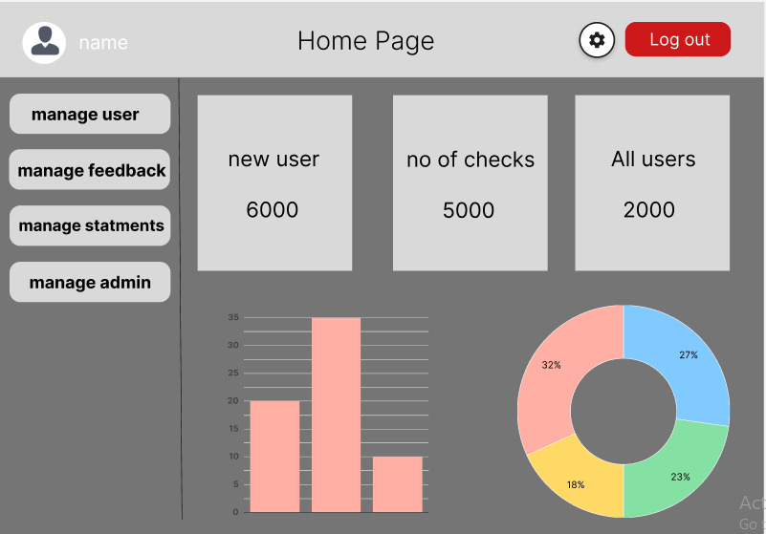In this we show number of new users started using application and numbers of checks also number of overall users

Admin Manages Users:

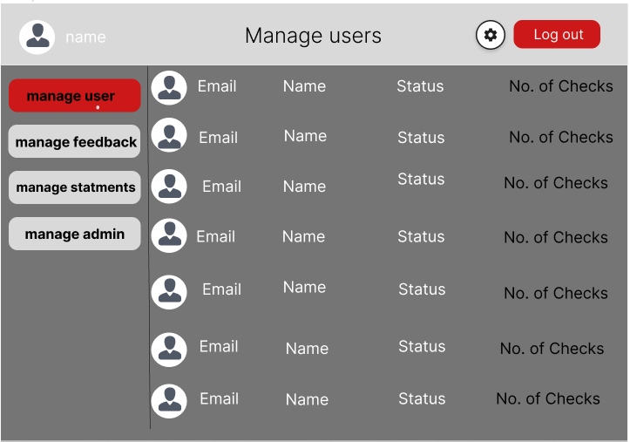  
when click on manage user gives him a grid with all users signed in application and give him brief about users

Admin can choose user from grid to see all his information and also can disactivate the user on system and submit changes

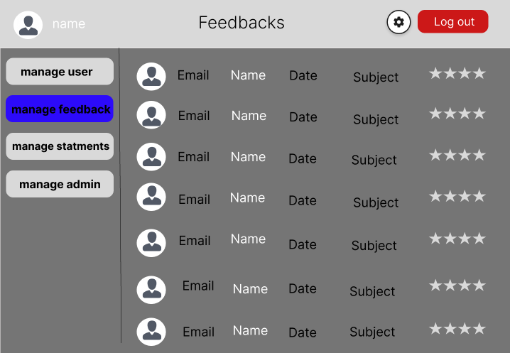

When user click on manage feedback give him a page which has a grid of users and its rate to see all users feedback’s

  
when admin click on one of users in grid gives admin user feedback and date of this feedback

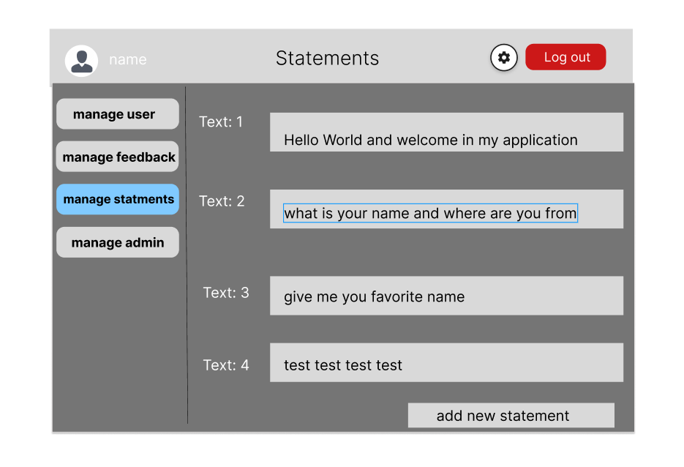

When admin click on manage statement can see statements which user use it to try the model, and also can add new statements in database

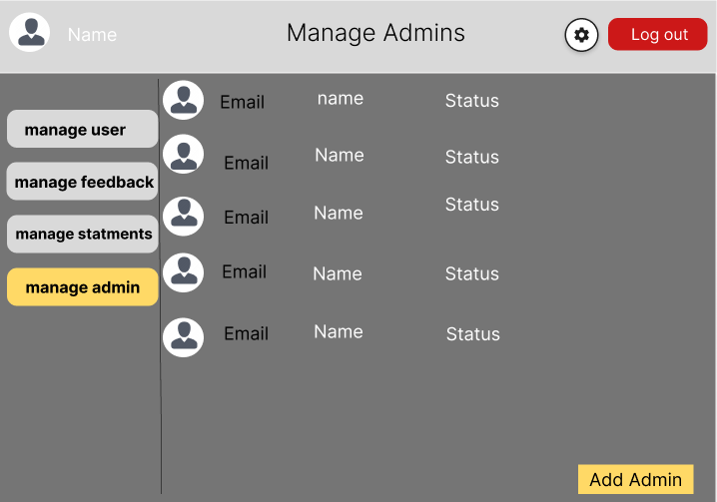When click on manage admin give him list of users

When click on manage admin give him list of users and when he click on one of them give him all his information and last log and last statements added

Here Admin can update his data change his name , phone number , photo , password .

User 2.1.1.2  
  
Sign Up page :  
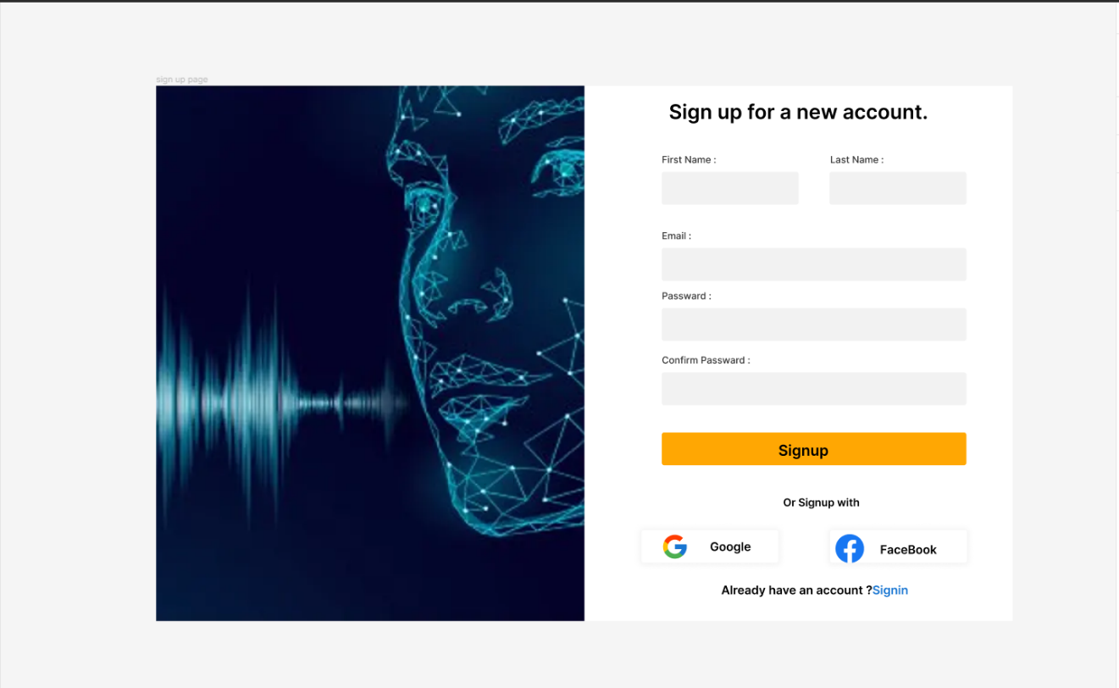

|  |  |
| --- | --- |
| **Users must login to use features of this application. Register page:**  This page has two different types of data:   * First type is mandatory such as (name, phone number, password and email.   Second type Gmail Account  **Validation** if you entered (Name/ Email/ Phone Number/ Password/ Re-Password / email) isn’t correct a warning message will be shown " (Name/  Email/ Phone Number/ Password/ Re-  Password, email ) isn't correct " | **Verification**  When user click on the Next, he will be moved to Home page . |

Login Page :

|  |  |
| --- | --- |
| **Log in:** Contains Email and password.    When user click on the Next, he will be moved to home page.    If the user is logged in before, he will be taken to the home page and this page will not appear.    Button bar disabled on this page, if user want to access feature of application, he must be to login. | **Home Page**  This page give him a brief of the website  and how to use it |
|  |  |

Home Page

This the user home page after the user login he will see buttons on the left side of the page screen and when he clicks on any button it will take him to desired page.

Voices Page :

In this page user enters his voice he can record it or upload it

Compare Audio Page :

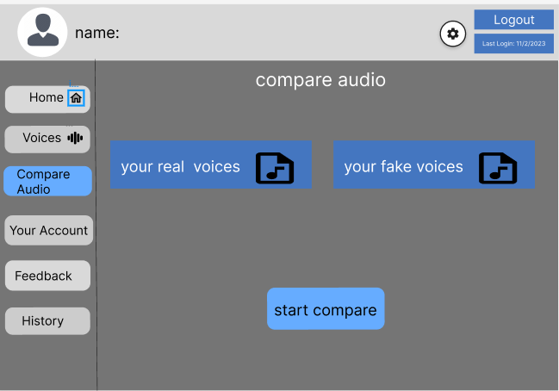

Here we upload voices to start the process of checking it real or not .

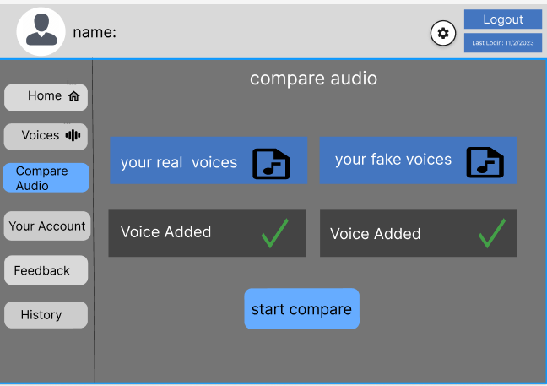

In this page we ensure that you added voices successfully and we are ready to check if it real voice or not .

In this page user choose a real voice record that he recorded before and input fake voice and the process started by comparing fake voices together then with real voices .

After analyzing the voices and enforcement our algorithms we generate a spectrograph that show all characteristics also show the accuracy and determine it fake or real voice .

User Account Page :

In the Account information page the user will be able to see his account his cover photo name, phone number, email

if user click on Update button he will has an access to update cover photo, name, phone No. ,email  
password

After user make his change should click on save to save the changes in database.

Feedback Page :

In this page the user will be able to write his feedback. So we can contact the user and do our best to improve our platform.

History page :

This is the history page this page is supposed to show the user cases. On clicking on a specific case it shows the case data which consist of real voice, fake voice and Spectrograph.

This page show us the cases of checks we done and their accuracy and date of performing it .

By clicking on any case , it automatically show us all details about the case .

This page shows the details of the case .

2.2 ) Non-Functional Requirements

-Performance  
 -The system should process audio recordings in a timely manner, delivering results within a reasonable time frame.  
- The system should be capable of handling multiple concurrent requests for analysis without significant performance degradation.

Accuracy  
- The system should strive for high accuracy in voice analysis and authenticity determination.  
- The accuracy of the system should be continually improved through regular updates and training with new data.

Scalability  
- The system should be designed to scale horizontally to accommodate increasing usage and growing datasets.  
- The system should support the addition of new analysis algorithms and techniques without requiring major architectural changes.

Security  
- The system should ensure the privacy and confidentiality of uploaded audio recordings.

- The system should implement secure data transmission and storage practices to protect sensitive information.

3.0  
conclusion :   
  
Fake Voice Detection System: The software application designed to identify and detect fake or manipulated voices in audio recordings .Authenticity: The measure of whether a voice is real or manipulated.  
Confidence Score: A numerical value representing the system's level of certainty about the authenticity determination. This Software Requirements Specification provides an overview of the key requirements for developing a Fake Voice Detection System. It serves as a foundation for the design, development, and implementation phases of the project. Detailed design, architecture, and implementation decisions will be made based on these requirements.